**ARN CARE LTD**

**PRINICIPAL CARERS AND SUPPORT SERVICES LTD**

**COMMENTS, SUGGESTIONS AND COMPLAINTS**

**Scope**

The procedure used in responding to comments, suggestions and complaints.

**Aims and Values**

• The agency and its staff value comments, suggestions and complaints from all sources.

• There is a satisfactory response to all comments, suggestions and complaints, in line with legal requirements and best practice.

• Service Users and carers know how to make comments, suggestions and complaints.

**Responsibilities**

The manager and senior staff.

**AWARENESS OF THE COMMENTS, SUGGESTIONS AND COMPLAINTS PROCEDURE**

• The service must nominate:

• A senior member of staff who is responsible for both the complaints policy and procedure and learning from complaints.

• A complaints manager who will manage communications with complainants

• The two roles may be carried out by the same member of staff.

• The nominated senior member of staff should be responsible for producing information regarding the operation of this procedure which is readily available. The format of the information should be simple to understand, and or in the preferred communication format of Service Users.

• If the Service User or family wish to make a complaint, they will be encouraged and supported to do so.

• The law requires the manager to publicise the complaints policy and ensure that people are aware of and understand how to make a complaint and how it will be processed and the timescales involved. Staff should refer to the Service Users Comments, Suggestions and Complaints Policy.

• The manager should ensure that copies of the Service Users Comments, Suggestions and Complaints Policy, with any other relevant information about how to make comments, suggestions and complaints, are given to all new and existing Service Users.

• All staff are aware that the investigations into complaints will be given equal weight regardless of the source or the persistent nature of the complaint.

• The manager must ensure that all staff know how to respond to a complaint.

**COMMENTS AND SUGGESTIONS**

When a positive comment is received by the agency, the manager should ensure that staff are made aware of the comments made and a record made in the comment Book

The manager should ensure that any letters received which express satisfaction with the agency or the services delivered within the agency should be displayed in a prominent place for a reasonable time so that visitors, Service Users and staff have the opportunity to read the comments made.

When the manager feels that the positive comments have been displayed for sufficient time, the card / letter should be removed and placed in a folder or file along with other such positive comments so as to form a permanent record of such comments.

When a suggestion is received, this should also be logged in the Comment Book to be raised as appropriate with relevant staff, at staff meetings and as part of the Management Review.

The manager should make a comments book available at reception to enable visitors to Service Users to record observations on care, treatment and support delivered by service. This is used by the management to improve services.

**SUPPORTING SERVICE USES TO UNDERSTAND THE COMPLAINTS PROCESS**

The manager makes Service Users aware that they wish to learn from Service Users about the quality of services that are provided. Service Users who are dissatisfied with the service are encouraged to make a complaint so that it can be addressed.

The complaints manager must ensure that that the person who is making the complaint is given every assistance to help them understand the complaints process or advice on where such assistance can be obtained including advocacy services. All complaints will be received by the manager compassionately and with sympathy.

The complaints manager will ensure that people who use the service are confident and feel comfortable that making a complaint will not cause them to be discriminated against or have any negative effect on their care, treatment or support.

Staff where appropriate will support Service Users in making a complaint using Complaints, Suggestions and Compliments Form. This allows the service user to record their own independent complaints, suggestions and compliments. Alternatively, if this is not appropriate, the Service’s manager can use Complaints Form to directly record a complaint, suggestion or compliment received from the Service User, their family or supporters.

**MANAGING AND INVESTIGATING COMPLAINTS**

People who wish to complain must do so within 12 months of an incident happening or of becoming aware of the matter complained about. They can also choose to complain to the local authority social care commissioner instead of the provider of the service.

The manager should ensure that the process for handling the complaint is conducted with openness and transparency whilst observing confidentiality.

When anyone makes a complaint about the agency or the services delivered by the agency, either verbally or in writing the complaints manager must acknowledge receipt of the complaint including the desired outcome and offer to discuss the nature of the complaint within 3 working days. Staff must make a record using a Complaints Form, and make an entry of the relevant details in the Complaints Log.

The manager must ensure that complainants are not discriminated against or victimised. In particular, people’s care and treatment must not be affected if they make a complaint, or if somebody complains on their behalf.

On receipt of a complaint appropriate action must be taken without delay to respond to any concerns or failures identified by a complaint or the investigation of a complaint.

The complaints manager should undertake an initial review to establish the level of investigation and immediate action required, including referral to appropriate authorities for investigation. This may include professional regulators or local authority safeguarding teams.

Where the service is informed of a complaint by another agency, i.e. the Care Quality Commission, or commissioner, who is dealing with a complaint on behalf of a complainant, or where the complaint involves another agency, all communications and correspondence regarding the process and outcome of the investigation will be copied to the agencies involved.

Where the manager receives a request from the Care Quality Commission for a summary of complaints and responses carried out by the service. The manager should review the Complaints Log, and investigation reports to gather the required information, which must be forwarded to the Care Quality Commission within the 28 days.

The complaints manager should set up a Complaints File, in which should be placed all information relating to the complaint and its subsequent investigation. If appropriate, a record may be made in the Person Centred Care Plan.

The complaints manager or nominated senior member of staff (who is competent to consider the issues raised and give reasons for conclusions reached) should lead the investigation into the complaint and write the conclusions when the investigation is complete.

The complaints manager, or the senior member of staff nominated by the manager, must carry out an efficient investigation that deals properly and appropriately with the complaint. The service must adopt a flexible approach to dealing with complaints which focus on the needs and wishes of the people involved.

There must be a documented audit trail that details the steps and decisions taken during the course of the investigation and records kept.

On completion of the investigation into the complaint, the complaints manager must write to the person who made the complaint explaining how the investigation was carried out and the appropriate action that has been taken. A copy of the letter should be retained on the Complaints File, and where appropriate with the Service User’s Care Plan File.

The complaints manager should seek feedback from the person who made the complaint on how they feel the complaint was dealt with. Where the person who made the complaint is not satisfied or is unhappy with the outcome, they must be reminded of their right to take the matter to the Local Authority Social Services or Local Government Ombudsman and refer to the Comments Suggestions and Complaints Flow Chart (section 11.0) about contact details.

Where complainants escalate their complaint externally because they are dissatisfied with the local outcome, the manager will cooperate with any independent review or process.

Where the manager receives an anonymous complaint the matter should be investigated as far as possible.

The manager will hold to account any staff member who is reported to have behaved in a discriminatory manner to the Service User or their family as a result of a complaint made against the agency.

**LEARNING FROM COMMENTS, SUGGESTIONS AND COMPLAINTS**

Complaints are reviewed wherever possible by staff who are not involved in the events that have led to the complaint.

The manager should ensure that all comments, suggestions and complaints are reviewed as part of the Management Review of the Quality System or at more frequent intervals where required by the manager.

The manager or nominated senior member of staff must produce an annual report that details complaints that have been received, the issues that have been raised, and actions that have been taken to improve practice including safety and quality as a result of the complaints. Evidence of improvement actions for CQC may be provided through risk management, changes to policies staff training and development programs.

When reporting to CQC about feedback on the quality of the service, the manager should take into account the views of staff, Service Users and others acting on their behalf about the quality of the service, risk and improvement plans.

**POLICY STATEMENT**

At ARN CARE LTD, we aim to ensure that our complaints procedure is implemented properly and effectively. We desire that service users feel confident that their complaints and concerns are paid attention to and acted upon fairly and promptly. Our complaints policy provides that:

• Service users, carers, relatives and representatives should be aware of how to make complaints and that ARN CARE LTD provides an enabling environment for complaints to be registered.

• A named person will be responsible to administer the procedure.

• Written complaints must be acknowledged within 2 working days.

• All complaints should be investigated within 28 days of being made. All complaints are responded to in writing by ARN CARE LTD within the stipulated 28 days.

We deal with complaints promptly and fairly. We are also sensitive as complaints can upset and cause our service users and staff to worry. The responsibility to follow complaints at ARN CARE LTD is on the Registered Manager.

At ARN CARE LTD, we believe that, wherever possible, complaints are best dealt with on a local level between the complainant and ARN CARE LTD. If one of the involved parties is not satisfied by the resolution of the local level process, then the case should be referred to the Care Quality Commission. Below is CQC contact:

www.cqc.org.uk/contact-us

Tel No.: 03000616161

FaxNo.: 03000616171

You can also contact a senior staff at ARN CARE LTD at:

**(Office 15, The Winning Box, Aquis House, 27-37 Station Rd, Hayes UB3 4DX)**

You can call us on: (**07471934203**, Mon-Friday, 9am -5pm)

Email: (Email: info@arncare.org get response within 48 hours)

NHS Constitution (DH, 2009)

The Principles of Good Complaint Handling (Parliamentary and Health Service Ombudsman, 2008)

Listening, improving, responding: a guide to better customer care (DH, 2009)

NHS Litigation Authority guidance about complaints

Being open – communicating patient safety incidents with patients and their carers (NPSA, 2009)

**11.0 COMMENTS, SUGGESTIONS AND COMPLAINTS PROCEDURE FLOWCHART**

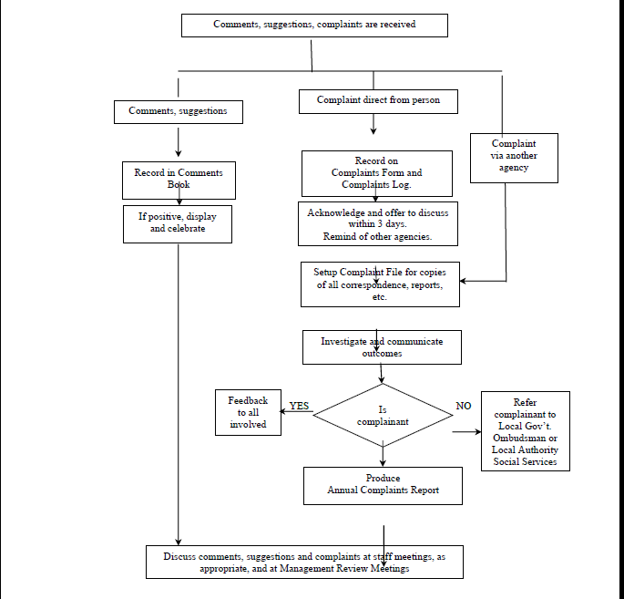

**Last Reviewed**

(20.06.2025)

Next Planned Review in 12 months, or sooner as required.

Approved by Rahma Mohamed Isse (**Registered Manager**)