

Easy Read Guide

Complaints and Concerns

Concerns and Complaints
This is our easy-to-read guide on how to make a complaint about our service.

What is a complaint?  A complaint is when you let us know you're unhappy with a service and want us to answer.  You might be unhappy because:  - We did something the wrong way.  - We did something we shouldn't have done.  - We didn’t do something we should have done. | 
We like to know what you think so please tell us  Please tell us what we can make better | 
Please tell us what you think is good | 
Please tell us what you think is bad | 
Many people can help you share your thoughts with us  - Family  - Friends  - Social worker  - Support worker  - Advocate | 
You can tell us in many different ways  - Email: info@arncare.org  - In person  - Telephone and Whatsapp  07471934203  - Letter to: R.Isse  ARN Care Ltd  The Winning Box,Aquis House  27-37 Station Road Hayes  UB3 4DX |       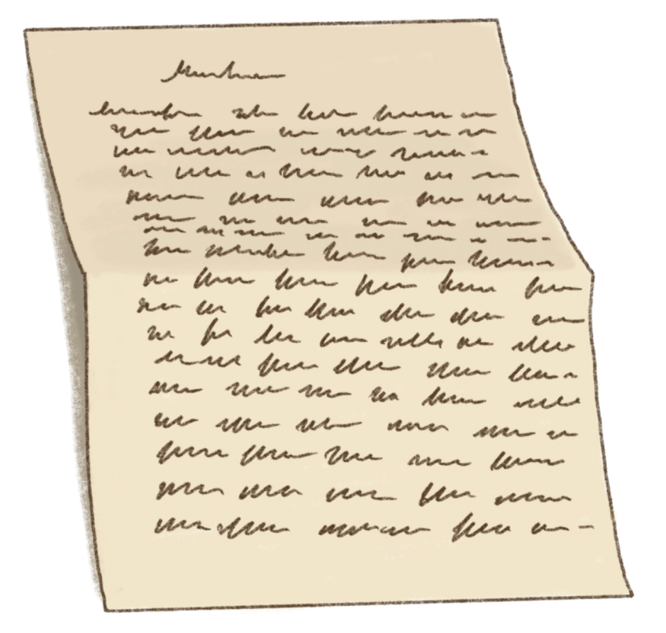
What happens after I make a complaint?  - Please don't worry  - We will always treat you fairly | 
- We want to make things better for you. | 
- We will send you a letter within 2 weekdays to let you know that we have received it | 
- We will discuss your complaint with you to make sure we clearly understand the problem.
- We will listen to everything you have told us | 
- We will tell you what we will do about it | 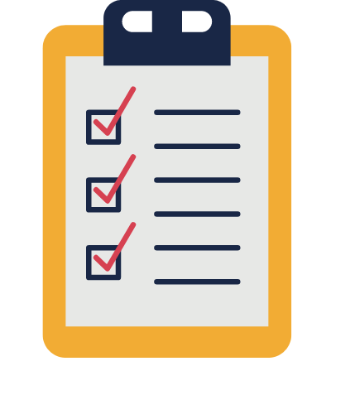
- We will answer your complaint within 1 month | 
If you are not happy with our response
- Please let us know
- We will help and let the right people know so they may help

